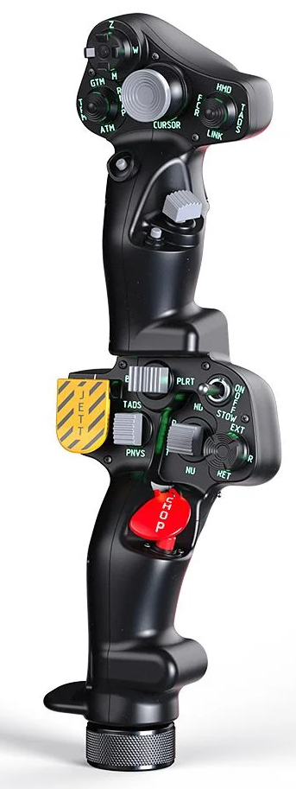  1xx - Controls | 2xx - Ground | 3xx - Flight | 4xx - A2A | 5xx - A2G | 6xx - Misc
102 - Controls - Pilot - Collective Grip Apache-64
U=Up, D=Down, F=Forward, B=Backward, L=Left, R=Right, P=Press, S-*=Shift-*, L-*=Long-*

Top Trigger
- P: --
FCR Scan hat (4-way + push)
- U: --
- D: --
- L: --
- R: --
- P: --
FCR Mode hat (4-way + push)
- U: --
- D: --
- L: --
- R: --
- P: --
Cursor hat (Ministick)
- Axes: --
- P: --
- U/D/L/R: --
Sight Select hat (4-way + push)
- U: --
- D: --
- L: --
- R: --
- P: --
Cursor Select button
- P: --
Cued Search button
- P: --
FCR Transmit hat (2-way spring return + push)
- F: --
- P: --
- B: --
Top Pinky button
- P: --
-------------------------------------------------------------------------------------------------------------------------------------
Bottom trigger
- P: --
Boresight rocker (2-way spring return + push)
- L: --
- P: --
- R: --
Searchlight switch (2-way toggle??)
- F: --
- B: --
Searchlight hat (4-way + push)
- U: --
- D: --
- L: --
- R: --
- P: --
Jettison button
- P: --
NVS switch (2-way spring return + push)
- F: --
- P: --
- B: --
Stabilator switch (2-way spring return + push)
- F: --
- P: --
- B: --
Chop button
- P: --
Bottom Pinky button
- P: --

